**Tutorial 46: Composition API vs Options API**

In the tutorial we are going to discuss the difference between Composition API and Options API.

We have been using the Options API to build our applications thus far. The Option API is a layout to creating components.

Here is an example of the Options API layout.

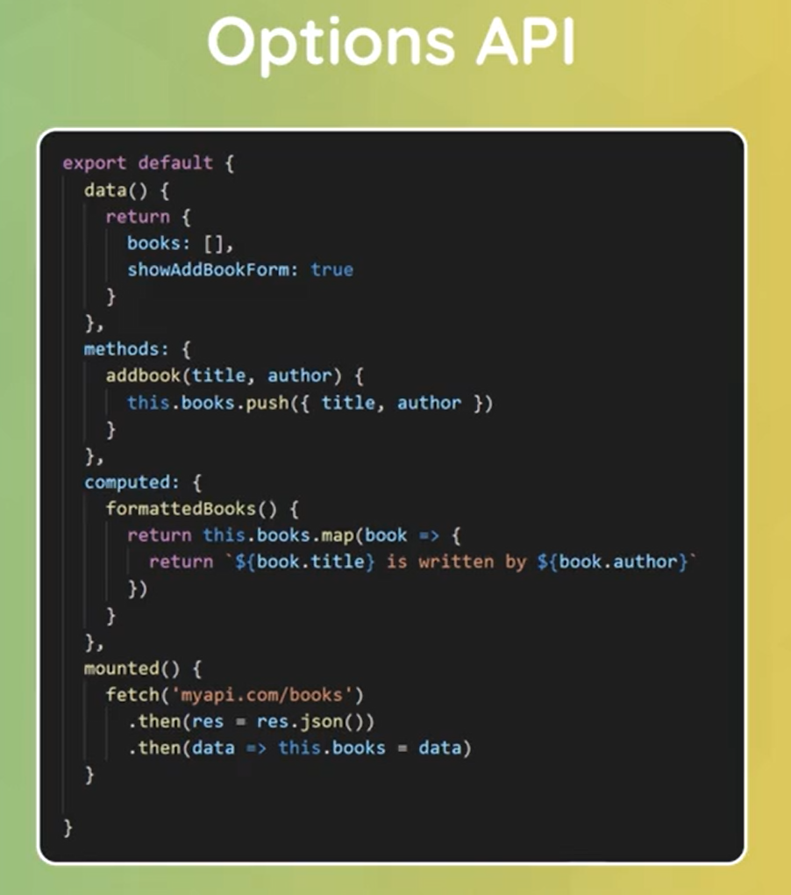

It comprises of a data function, a methods property, computed property, and lifecycle hooks. These are all added directly to the component object which we export.

This has been the way Vue applications were made in the past few years. It is still relevant and current way of creating applications with Vue. However, with the release of Vue 3, Vue now allows us another way to create Vue applications with the Composition API.

A composition API gives access to a setup function inside the component object. Inside the setup is where we would put all of our component data functions, methods property, computed property and lifecycle hooks.

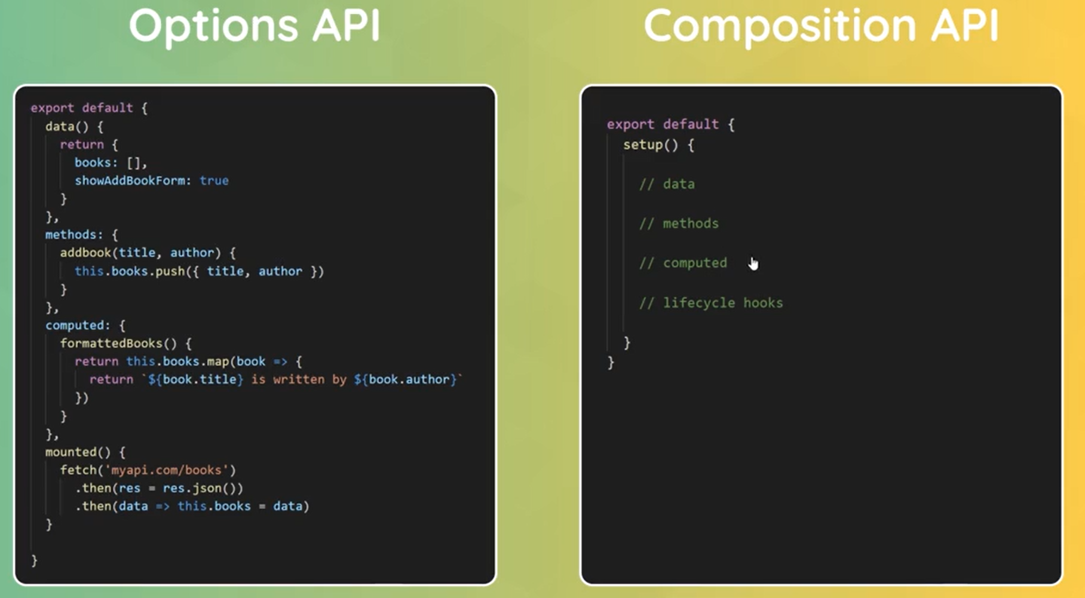

The disadvantage of the Options API, is that it is much more difficult to group feature logic together. For example, for a component getting data and then formatting data, we would have three moving parts, we would have the data itself, we would have the data itself, we would have a computer property and a lifecycle.

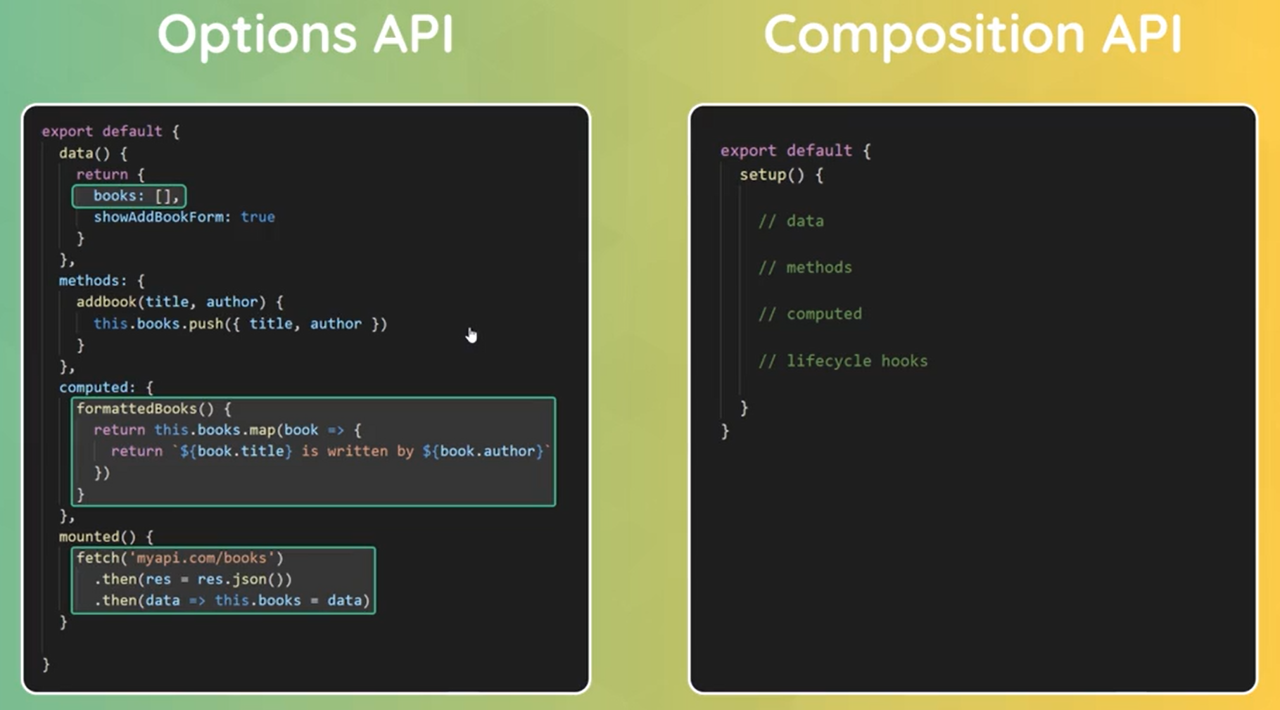

]

With the Composition API, you can organise the code in such a way that groups feature logic.

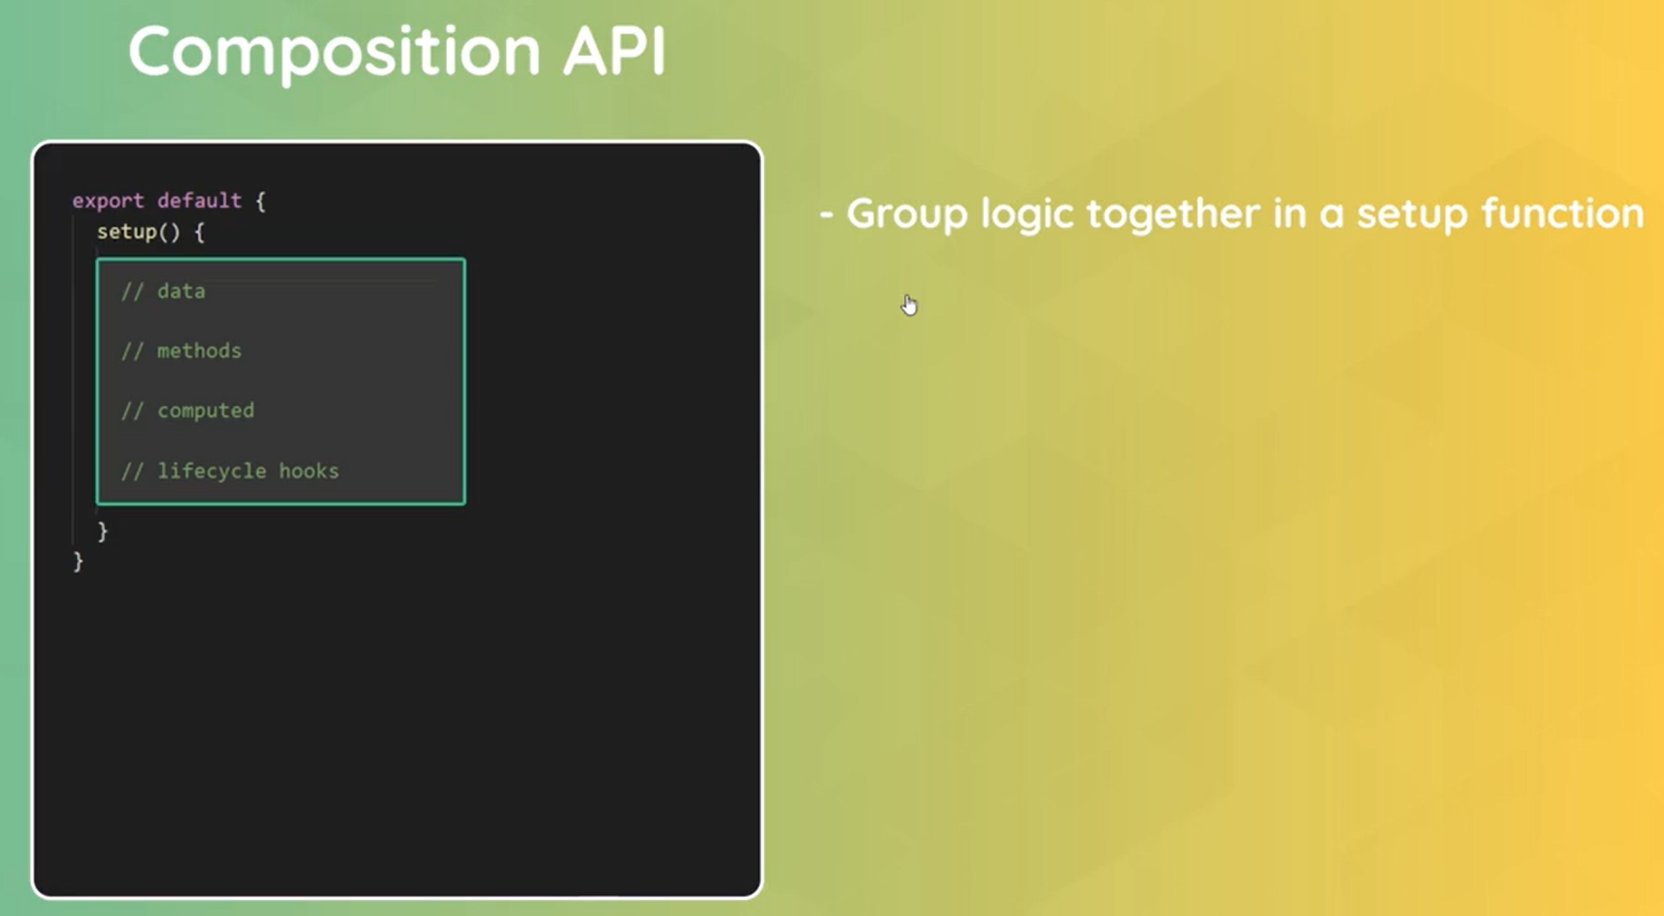

With the Composition API, we can easily create reusable logic and code with composition functions.

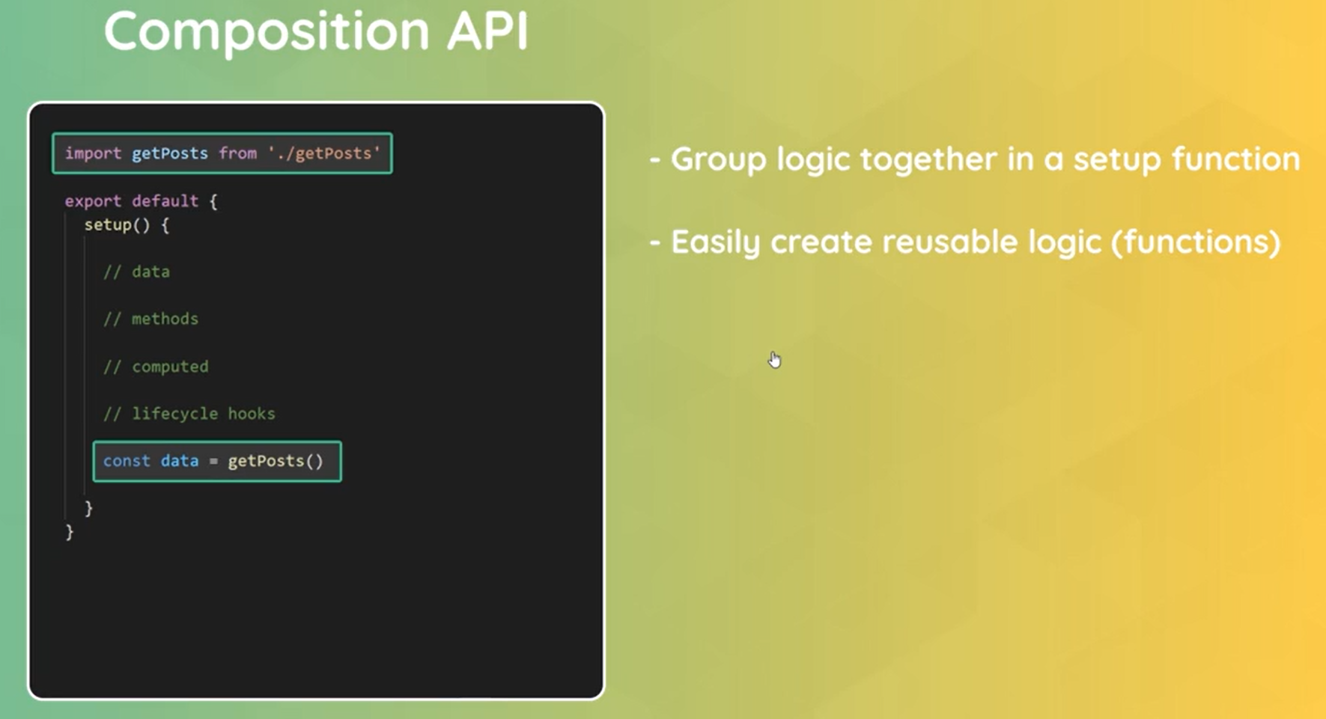

Using Compositions API is better choice when building large projects which require a bit more organisation, more reusable code and more complex logic.

It is possible to use a combination of both Options API and Compositions API. The Composition API could be used for some logic and still use the Options API for simple logic.